# Day 4 - Create Groups and Apply AGDLP

1.**Read about the three group scopes before creating anything:**
- **Domain Local** — used to grant actual permissions to resources (files, printers, shares) within the domain they're created in; can contain members from any trusted domain
- **Global** — used to organize users who share a role (e.g. "all Sales staff"); replicates only within its own domain; the scope departmental groups almost always use
- **Universal** — used in multi-domain forests to group objects across domains; replicates to the Global Catalog forest-wide, so it's used sparingly on purpose

2. **Create one Global security group per department**

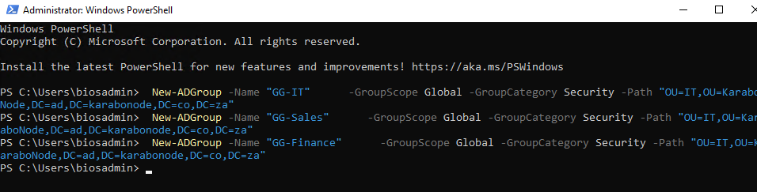
`GG-` is a naming convention flag for "Global Group

3. **Add each user to their matching group:**

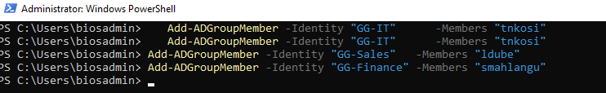

*Write a one-paragraph explanation of the AGDLP nesting pattern**
A- ACCOUNTS
G – GROUPS
DL – DOMAIN LOCAL GROUPS
P – PERMISSIONS

So this is the strategy used by active directory to manage groups in a clean and scalable way. Instead of you giving the user or managing user permissions indivually, youll create the groups and add the users in the group and only manage the group’s permissions instead of manually managing each user. If new user is added to the group, the user will inherit the permissions from the user

## Skills covered
`New-ADGroup` / `Add-ADGroupMember`, the three group-scope semantics (Domain Local / Global / Universal), the AGDLP nesting pattern used for real-world permission delegation.

